1. **(Its Working per the Scenario and Discussion) Alphabet “**T”**Not Working in "What Comes After, Before, and Between" Sections**

**Issue Type**:

**Issue Link** : <https://screenrec.com/share/dv8DobswEy>  
Bug

**Description**:  
When a user logs into the mobile app and navigates to the **Play with Letters** section, the Alphabet “**T** “ does not produce any response when selected in the following subsections:

* **What Comes After**
* **What Comes Before**
* **What Comes Between**

**Steps to Reproduce**:

1. Log in to the mobile app with valid credentials.
2. Navigate to the **Play with Letters** section.
3. Click on **What Comes After** and select the Alphabet T.
   * Observe that no response or feedback is shown.
4. Click on **What Comes Before** and select the Alphabet T.
   * Observe that no response or feedback is shown.
5. Click on **What Comes in Between** and select the Alphabet T.
   * Observe that no response or feedback is shown.

**Expected Result**:

* For **What Comes After**: The app should correctly display "U" as the next letter after "T."
* For **What Comes Before**: The app should correctly display "S" as the previous letter before "T."
* For **What Comes Between**: If two letters (e.g., S and U) are provided, the app should correctly identify "T" as the letter between them.

**Actual Result**:

* No response or feedback is displayed when the Alphabet T is selected in any of the subsections.

**2**. **(Not Working)**

.**Next View" Not Working While Selecting Alphabet A in Magic Letter**

**Issue Type**:  
Bug

**Description**:  
In the **Magic Letter** section of the mobile app, when the user selects **Alphabet A** and clicks on the **Next View** button,

**Steps to Reproduce**:

1. Log in to the mobile app with valid credentials.
2. Navigate to the **Magic Letter** section.
3. Select **Alphabet A**.
4. Click on the **Next View** button to proceed to the next slide.

**Expected Result**:  
Clicking on the **Next View** button should move the user to the next slide.

**Actual Result**:  
The **Next View** button does not work when Alphabet A is selected, and the screen remains stuck.



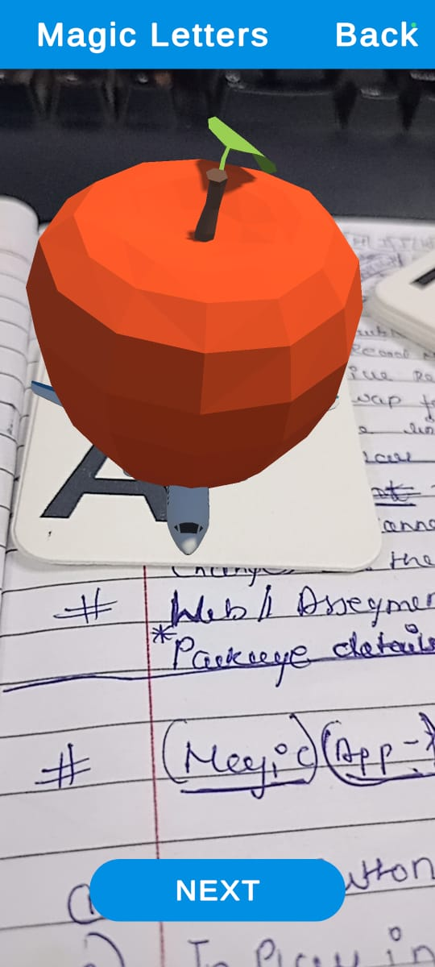

**(Not Working)**

**Alphabet "I<K<N<P<F<H" Does Not Change and Only Displays One Content**

**Description**:  
When interacting with the Alphabet "I<K<N<P<F<H" in the app, the displayed content does not change as expected. Instead, it remains static and shows only a single piece of content, regardless of user actions.

**Steps to Reproduce**:

1. Log in to the mobile app with valid credentials.
2. Navigate to the **Play with Letters** section.
3. Select the Alphabet "I" from the list.
4. Observe the displayed content and attempt to interact with it.

**Expected Result**:  
The content for the Alphabet "I" should dynamically change based on the user’s interaction, similar to other alphabets.

**Actual Result**:  
The Alphabet "I" does not change and continuously displays only one piece of content.

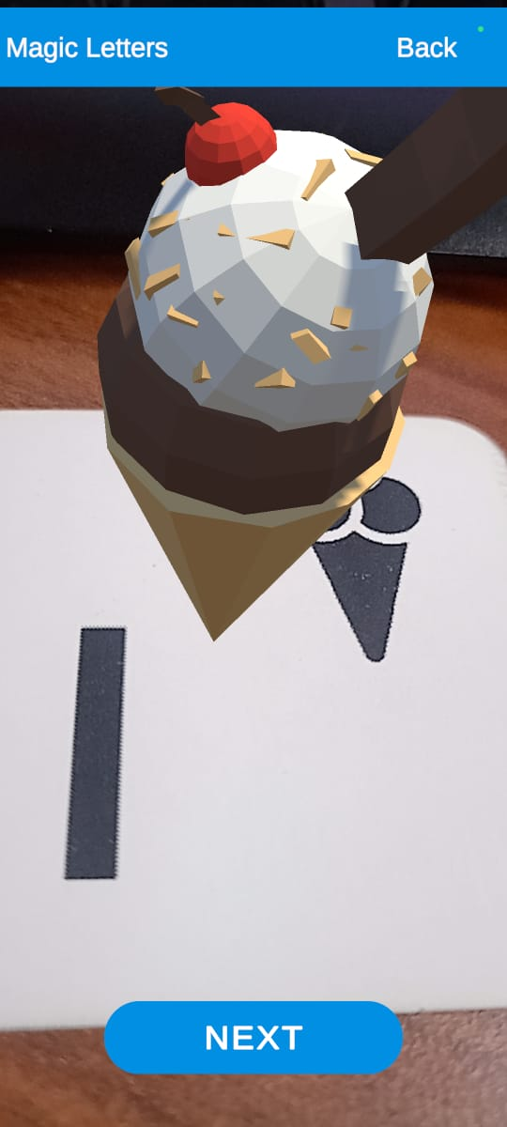

**3.(Its Working per the Scenario and Discussion)**

**Play with Numbers" Button Not Working in Mobile App**

**Issue Type**:  
Bug

**Description**:  
When the user clicks on the **Play with Numbers** button in the mobile app, there is no response. The button does not trigger any action or navigate to the intended section, making the feature inaccessible.

**Steps to Reproduce**:

1. Log in to the mobile app with valid credentials.
2. Navigate to the section containing the **Play with Numbers** button.
3. Click on the **Play with Numbers** button.
4. Observe that the button does not respond or navigate to any page.

**Expected Result**:  
Clicking the **Play with Numbers** button should navigate the user to the **Play with Numbers** section successfully.

**Actual Result**:  
The **Play with Numbers** button does not respond, and the user remains on the current screen.



**4. (Its Working per the Scenario and Discussion)**

**Back Button Redirects to Splash Screen & Device back button is Not Clickable its should be functional same as back button (back is only for one screen back)**

Issue Link : <https://screenrec.com/share/gNlGS7DRrk>

**Issue Type**:  
Bug

**Description**:  
When the user navigates to any section under **Magic Letters** **,Play with letter** (e.g., **What Comes After**, **What Comes Before**, or **What Comes in Between**) and clicks on the **Back** button, two issues are observed:

1. The app redirects to the **Splash Screen**  instead of returning to the Magic Letters main screen.
2. Sometimes, the **Back** button becomes **non-clickable**, and the user cannot navigate at all.

**Steps to Reproduce**:

1. Log in to the mobile app with valid credentials.
2. Navigate to the **Magic Letters** section.
3. Select any option:
   * **What Comes After**
   * **What Comes Before**
   * **What Comes in Between**.
4. Click the **Back** button on the device.
5. Observe:
   * The user is redirected to the **Splash Screen** (unexpected behavior).
   * In some cases, the **Back** button is unresponsive (non-clickable).

**Expected Result**:  
Clicking the **Back** button In the Mobile devices should consistently return the user to the previous screen

**Actual Result**:

* The **Back** button either:
  1. Redirects to the **Splash Screen**.
  2. Becomes non-clickable

**5.(Its Working per the Scenario and Discussion)**

**The activity list should be dynamic for both 'play with letters' & 'play with numbers'.**

**Expected Result**:

Activity list of 'play with letters' should be dynamic it should come from api currently showing fix 3 activity

and also incorrect image image is also available in API

and same thing we have to do for play with numbers list should be dynamic it should come from api

**6.On Every attempt of activity there is API “Save Activity Step State” should be called.**

**Expected Result**:

On every attempt of any activity need to call save stat api no matter result is correct or incorrect

### **7. (Not Working ) (3)**

### **Play with Numbers: No Response for Number "1"**

**Description**:  
When the user clicks on the **Play with Numbers** button and scans the number "1", there is no response or feedback. Other numbers work as expected, but "1" fails to trigger any action.

**Steps to Reproduce**:

1. Log in to the mobile app with valid credentials.
2. Navigate to the **Play with Numbers** section.
3. Start the scanning activity.
4. Scan the number "1".
5. Observe that no response or feedback is displayed.

**Expected Result**:  
When scanning the number "1", the app should provide the appropriate response

**Actual Result**:  
No response is triggered when scanning the number "1".

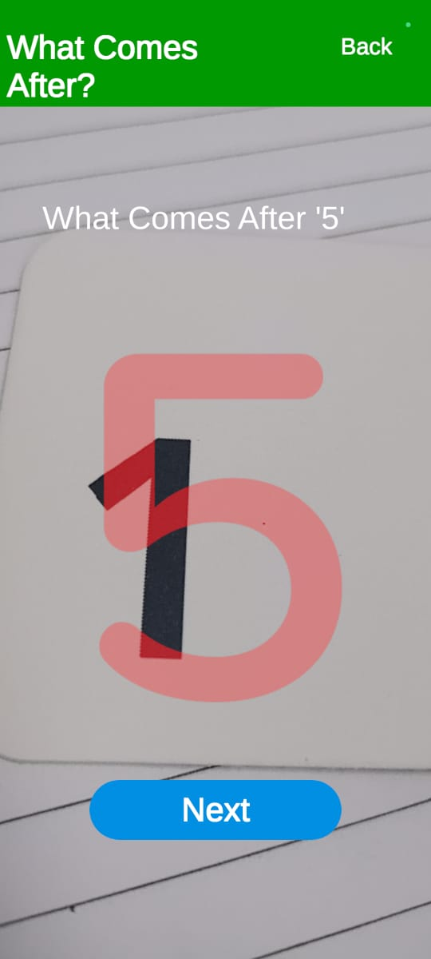

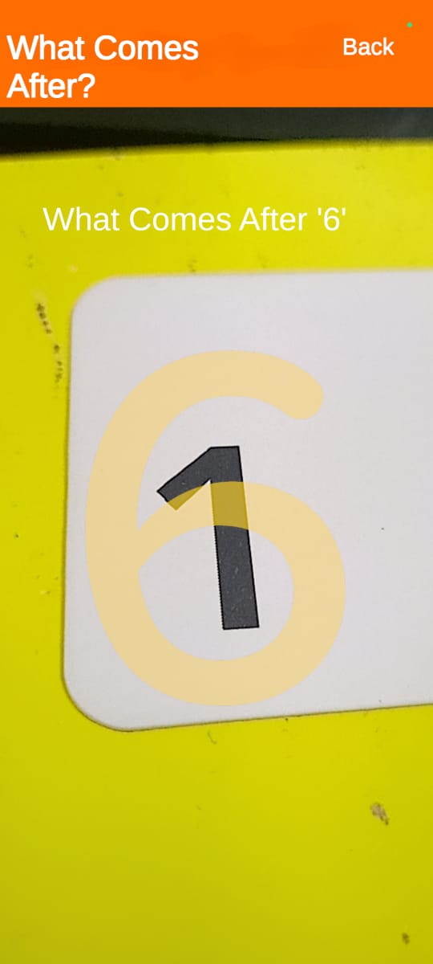

**8. Play with number : Responsiveness is Not Working**

**As per expected in What Come After,What Come before’,What Comes in Between.**

### **9: (Its Working per the Scenario and Discussion)**

### **Incorrect Heading Displayed for "What Comes in Between"**

**Description**:  
When the user clicks on **Play with Letters** and selects the **What Comes in Between** section, the main heading at the top incorrectly displays **What Comes Before** instead of the expected **What Comes in Between**.

**Steps to Reproduce**:

1. Log in to the mobile app with valid credentials.
2. Navigate to the **Play with Letters** section.
3. Select the **What Comes in Between** option.
4. Observe the main heading displayed at the top of the page.

**Expected Result**:  
The main heading should correctly display **What Comes in Between** when this option is selected.

**Actual Result**:  
The main heading incorrectly displays **What Comes Before** instead.

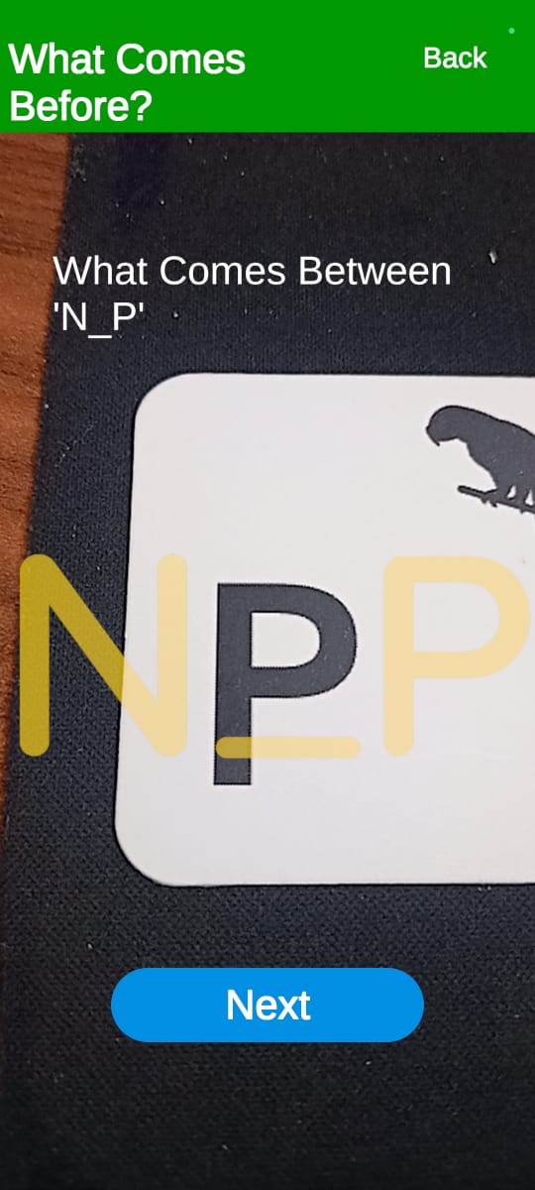

### **10.(Its Working per the Scenario and Discussion)**

### **No Response for "What Comes After"**

Description:  
When the user clicks on Play with Letters and selects the What Comes After section, there is no response or feedback displayed..

Steps to Reproduce:

1. Log in to the mobile app with valid credentials.
2. Navigate to the Play with Letters section.
3. Select the What Comes After option.
4. Observe the lack of response.

**Expected Result**:  
The app should provide the appropriate response or feedback (e.g., correct/incorrect answer,) when interacting with t**he What Comes After section.**

**Actual Result:**  
No response or feedback is displayed.



**10.(Its Working per the Scenario and Discussion)**

**Incorrect Main Heading Displayed for "Play with Numbers"**

Description:

When the user clicks on the Play with Numbers section, the main heading at the top incorrectly displays Play with Letters instead of the expected Play with Numbers. This creates confusion for users and affects the clarity of the interface.

Steps to Reproduce:

1. Log in to the mobile app with valid credentials.
2. Navigate to the Play with Numbers section.
3. Observe the main heading displayed at the top of the page.

Expected Result:  
The main heading should display Play with Numbers when this section is selected.

Actual Result:  
The main heading incorrectly displays Play with Letters instead.

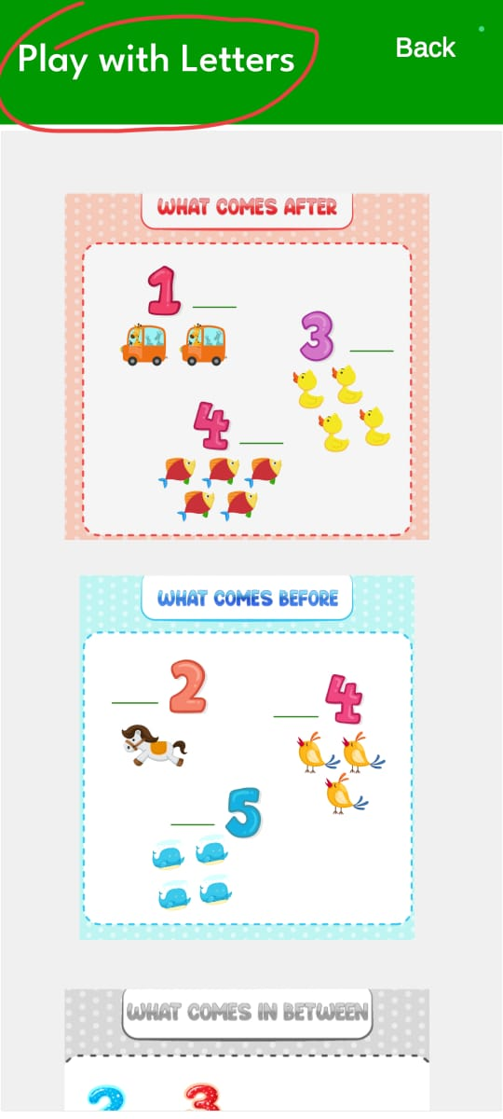

**11. (Its Working per the Scenario and Discussion)**

**Incorrect Section Displayed: "Play with Numbers" Displayed When "Play with Letters" is Selected**

**Description**:`When the user clicks on **Play with Letters**, the app incorrectly navigates to the **Play with Numbers** section instead.

**Steps to Reproduce**:

1. Log in to the mobile app with valid credentials.
2. Navigate to the **Play with Letters** section by clicking on its button.
3. Observe that the app displays content from the **Play with Numbers** section instead of the expected **Play with Letters** content.

**Expected Result**:  
When the user clicks on **Play with Letters**, the app should display the corresponding section with the letters-based activities.

**Actual Result**:  
The app incorrectly navigates to the **Play with Numbers** section instead.

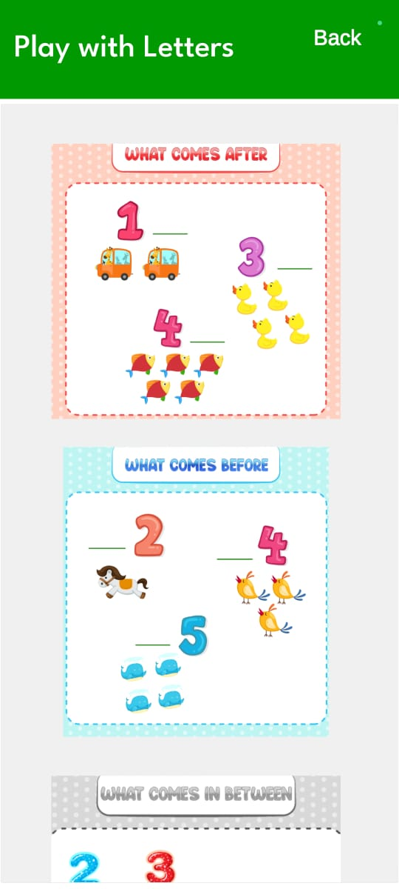

***New Bugs ;***

**12. (Its Working per the Scenario and Discussion)**

**Font Size Mismatch in "Play with Letters" and "Play with Numbers" Sections**

The font size in the **Play with Letters** and **Play with Numbers** sections does not match the expected font size, causing inconsistency in the user interface.

**Steps to Reproduce**:

1. Log in to the mobile app with valid credentials.
2. Navigate to the **Play with Letters** section.
3. Observe the font size
4. Navigate to the **Play with Numbers** section.
5. Compare the font size in both sections

**Expected Result**:  
The font size in **Play with Letters** and **Play with Numbers** should match the design specifications

**Actual Result**:  
The font size in **Play with Letters** and **Play with Numbers** does not match the expected size,

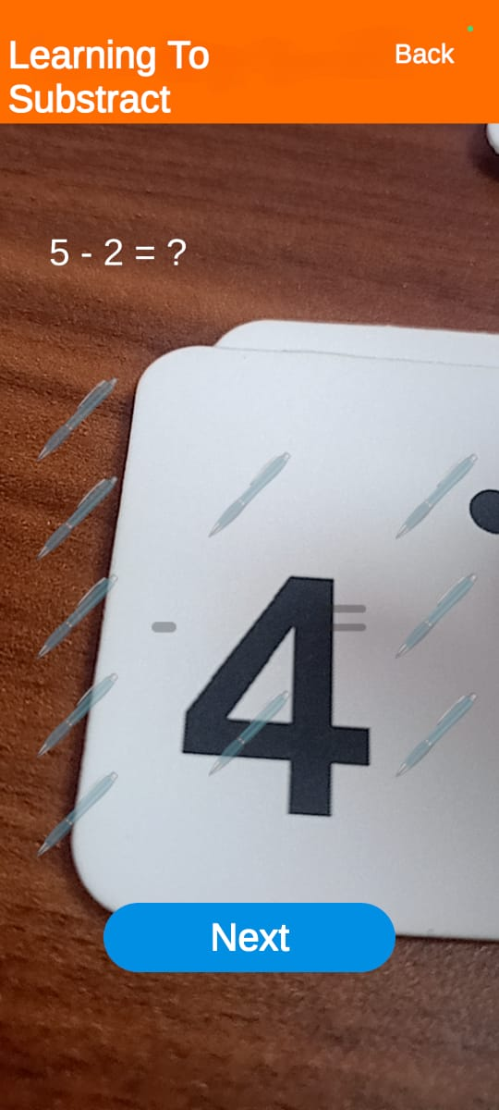

**13. (Its Working per the Scenario and Discussion)**

**Mismatch Between Numbers and Corresponding Images in "Learning to Add-Subtract" Section**

**Description**:  
When the user clicks on the **Learning to Add,Subtract** button, the numbers displayed do not match their corresponding images.

**Steps to Reproduce**:

1. Log in to the mobile app with valid credentials.
2. Navigate to the **Learning to Add,Subtract,** section.
3. Select any number from the provided options.
4. Observe the image displayed alongside the selected number.

**Expected Result**:  
The number should correctly match the corresponding image,

**Actual Result**:  
The number does not match the corresponding image,

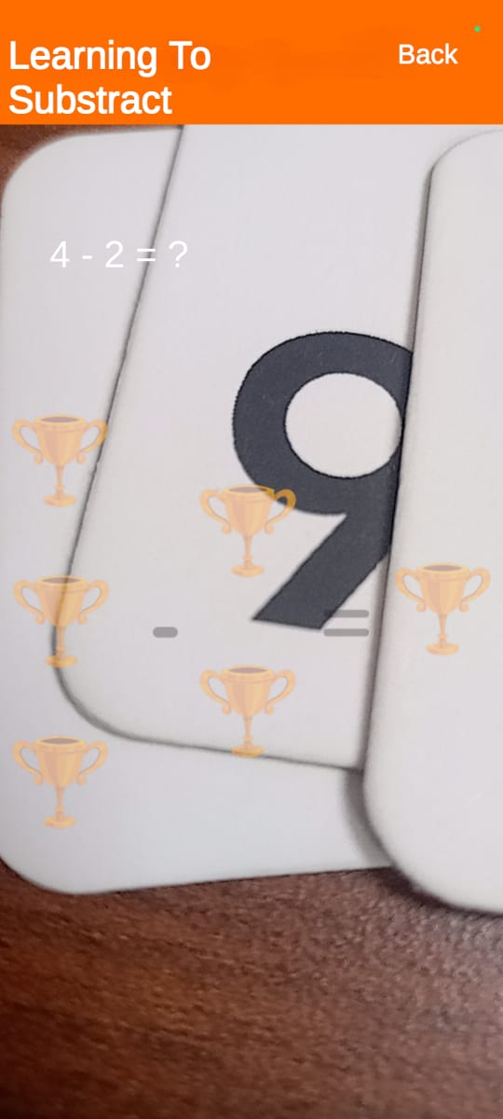

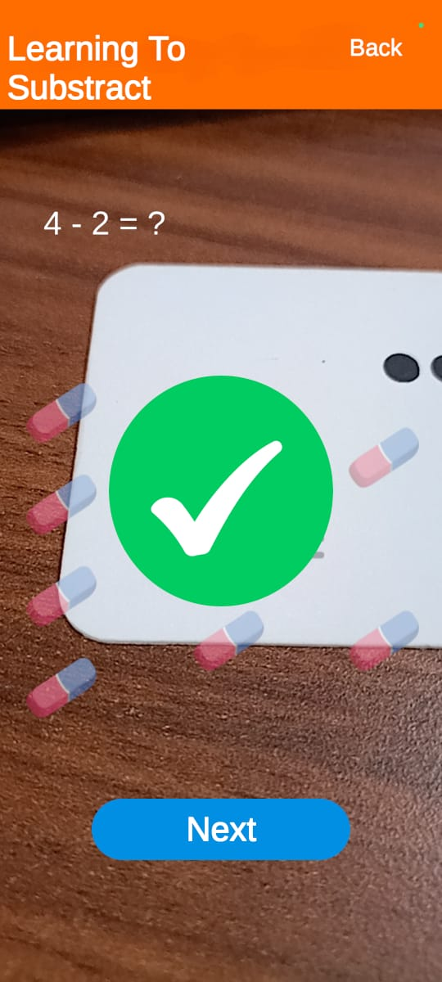

**14.(Not Working ) (3)**

**Number "1" Does Not Respond in "Learn to Subtract" Under "Play with Numbers"**

**Description**:  
When the user selects **Play with Numbers** and clicks on the **Learn to Subtract** button, the number "1" does not display any response while scanning the NUmber.

**Steps to Reproduce**:

1. Log in to the mobile app with valid credentials.
2. Navigate to the **Play with Numbers** section.
3. Click on the **Learn to Subtract** button.
4. Select the number "1" from the options.
5. Observe the behavior when interacting with the number "1".

**Expected Result**:  
The number "1" should respond appropriately, displaying the correct behavior when scanned in the **Learn to Subtract** section.

**Actual Result**:  
The number "1" does not display any response when selected or scanned in the tab.

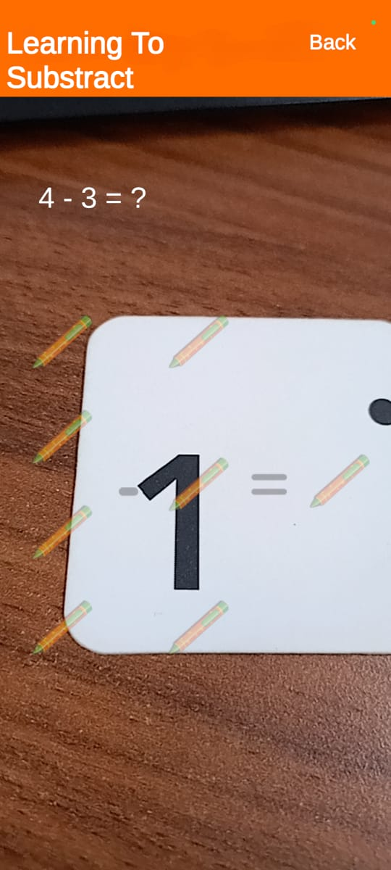

**15.(Not Working )**

**"Play with Number" Does Not Navigate to the Correct Tab**

**Description**:  
When the user clicks on the **Play with Number** option and then selects a tab, the app fails to navigate to the correct corresponding tab as expected.   
  
**Issue :** While opening the ‘**Play with Number**’ the list of activities not showing from the first activity, its scroll down at mid and showing activity list from mid.  
It's properly working in “**Play with Letters**”

**Steps to Reproduce**:

1. Log in to the mobile app with valid credentials.
2. Navigate to the **Play with Number** section.
3. It's not showing the first activity for the first activity we have to scroll up each time.

**Expected Result**:  
The app should open the selected tab and display the corresponding content or functionality.

**Actual Result**:  
The app does not open the correct tab; instead, it either fails to respond or opens an unrelated tab.

